Lesson 3 - Exercises

**Exercise 1**

**Question 1**

You should attempt to answer these questions without running the code in your browser. A) When the following code runs, what will be displayed in the console, and why?

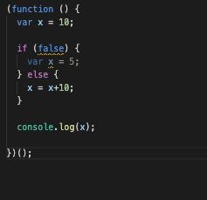

**What would display if we had the console.log(x) outside of the IIFEE**

**Question 2**

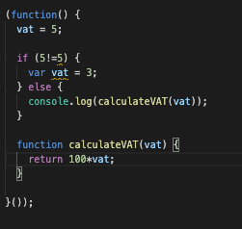

Question 3

**What will be the output of the code below:**

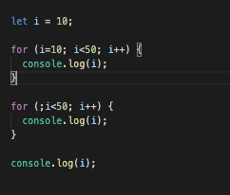

**Exercise 2**

**Re write the following code to use closures instead**

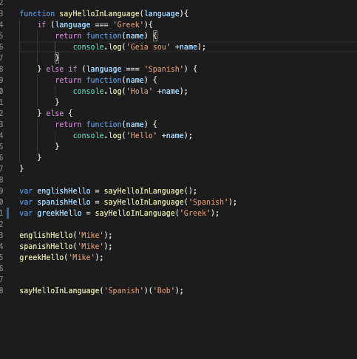

**Exercise 3**

**Write the missing code for the following code**

